ANCIENT WOODLAND CLUSTER MAPPING - summary

BACKGROUND

- The East of England has an estimated 19,000ha of Ancient Semi-Natural Woodlands (ASNW) and 8,000ha of Planted Semi-Natural Woodland Sites (PAWS), the majority of which lack formal management regimes. An overview of ancient woodlands is given in Annex 1.

- The Region has Biodiversity Action Plan targets of expanding and restoring three woodland habitats:
- Lowland Mixed Deciduous Woodland
- Lowland wood-pasture and parkland
- Wet woodlands

- In order to achieve these targets it is proposed that resources might be focused onto those priority areas where most can be achieved. Little strategic information is available on where these priority areas for restoration or expansion of ancient woodland should be.

- Norfolk Wildlife Services was contracted by the Forestry Commission in April 2002 to identify Ancient Woodland Clusters within the East of England. The work was completed by The Wildlife Trusts for Cambridgeshire and Bedfordshire, EECOS (Essex Wildlife Trust's consultancy), Suffolk Wildlife Trust, LandMASS (Hertfordshire Wildlife Trust's consultancy) and the contract managed by Norfolk Wildlife Services (Norfolk Wildlife Trust's consultancy).

PROJECT METHODOLOGY

- The project was essentially a consultation and opportunity mapping exercise, using stakeholder meetings with computer based Geographical Information System (GIS) as a visioning and analytical tool. The initial objective of the work was to identify whether, and where, clusters of ancient woodland could steer energy and resources for restoration and expansion of ASNW. The target output was for three clusters of Ancient Woodland (consisting of ASNW and/or PAWS) in each of the six counties in East England (i.e. 18 clusters in total).

- It was agreed early on during the process that two of the BAPs, Lowland wood-pasture and parkland and Wet woodlands, would be excluded from the specific consideration within the work, because of the differing stakeholder groups and specialist issues involved in them. They would though be considered if present incidentally in potential cluster areas.

- The methodology for the work consisted of the following stages:

- Liaison with regional FC staff to establish an outline methodology for the work. Some initial investigation of clusters was made using GIS and a stakeholder list established.

- A regional scoping exercise where the existing methodology for the work was refined and linkage to similar habitat mapping projects established.

- A local scoping exercise in each of the six counties, being Bedfordshire, Cambridgeshire, Essex, Hertfordshire, Norfolk and Suffolk.

- Collation of the scoping meeting results and use of GIS where appropriate to further confirm findings.

PROJECT OUTPUTS

- Response of nearly all local attendees was very positive towards the concept of clusters. This was prevalent to such an extent that in general the expectations of the consultees appear to exceed that of the Forestry Commission.

- In practice the local meetings often appeared to deviate from the identification of six clusters and selection of three from these. This occurred for a variety of reasons including disquiet about the concept of prioritisation to a lack of obvious candidate sites.

- The possible cluster groups identified for each county by the local scoping meetings are given in Map 1 and Annex 2. Where a decision was made on ranking the cluster the first and second priority clusters are also shown.

- Based upon the prior work from the regional and local scoping meetings a list of criteria that would be helpful in ranking the clusters was created. It was agreed that the ranking be as transparent as possible so that it can be revised if required and that it should be based on a scoring system.

- The list of all criteria was therefore reduced to five, these being either calculated (quantitative) or to be based on value judgements (qualitative). These were:

- The density of all Ancient Semi-Natural Woodland to reflect the overall resource of woodland present and the ability to connect and buffer these woodlands (quantitative).
- The potential need for restoration reflected by the proportion of woodland that was PAWS (quantitative)
- The potential for multiple benefits from woodland management within area for social options and public benefit (qualitative)
- The potential benefits for the landscape (qualitative)
- The complementary effects upon surrounding habitats for example semi-natural system/mosaics (qualitative).

- The quantitative criteria were calculated using a GIS. In order to avoid extensive work on agreeing boundaries for the clusters a decision was made to use center or hub points instead of these boundaries in calculating GIS statistics for the clusters.

- All the centre points and names for the clusters were collated into the GIS and confirmed with the local partners as being correct. From this a technique called kernelling was used from this center point to calculate the densities within a five-kilometer radius for each cluster of:

- the density of all Ancient Woodland present,
- the density of PAWS present.

- In addition a sample set of random points was made to allow the comparison of the density within the clusters to the average for the counties and region. Within each county 5,000 random points were located to allow for a comparison with the county and regional averages.

- Annex 3 identifies the “score” of the various clusters.

DISCUSSION

- In general there appears to be broad support (from those canvassed) for the use of a cluster approach to act in focusing effort and resources onto specific areas where visible results can be achieved on the ground. The differences in viewpoint were in how these clusters should function in terms of what they would deliver and how this would be achieved.

- These viewpoints varied between the counties with the most obvious continuum being between well-wooded counties such as Hertfordshire - where woodland restoration may be more of an issue - and sparsely wooded counties, such as Norfolk and Cambridgeshire, where buffering and connection between Ancient Woodlands is seen as being more important.

- The selection of the actual locations for the clusters appears to be relatively uncontroversial.

- The choice of cluster locations generally seemed to be less clear within Hertfordshire and Suffolk, where there were greater potential choices and the difficulties in defining a cluster were greater. Within Essex the selection of representative clusters from all the differing natural areas was seen as being important once this had been achieved. Within Norfolk and Cambridgeshire the number of potential clusters was few and in general all of them can be easily encompassed within the work.

- Should the Forestry Commission decide to the use of clusters for some targeted action, we will need to have them clearly defined. This process may need to be taken to further consultation before final solutions are met, although one solution is use to use parish boundaries to define the “area of interest”.

- Prioritisation of clusters was looked at as part of the work. The issue of prioritisation between counties is difficult, because there was not broad agreement as to the route in which prioritisation would occur within each county.

- The viewpoints expressed during the scoping exercise would appear to indicate broader aspirations for the progress of Ancient Woodland clusters within the East of England than was envisaged by the Forestry Commission within their original brief for this contract.

- The targeting of grant aid by Forestry Commission to these clusters may be an option, but this may not be able to achieve the aspirations of the potential partners. In consequence it may be an additional option for the Forestry Commission to develop a stronger partnership approach in developing the clusters as areas of woodland importance, either through a regional framework or through funding of project work within the individual clusters. A broader partnership approach would appear to have strong support, and in which it is suggested the Forestry Commission can play a key role.

Map 1
Location and names of clusters
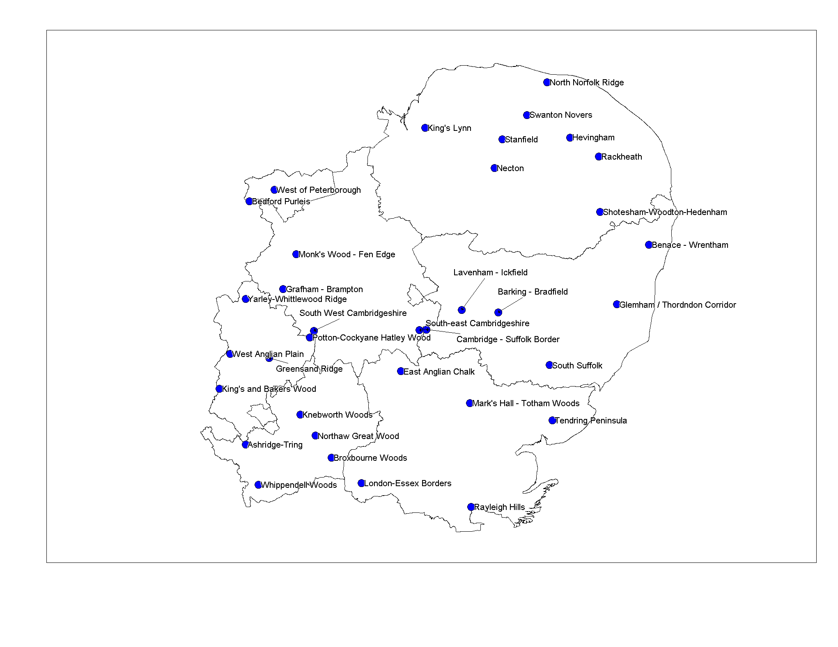

Annex 1

Area of Ancient and ASNW Woodland in hectares the East of England
(Source: Forestry Commission 1998) after DEFRA (2000)

County | Ancient  Woodland | % of all woodland | **ASNW | % of all woodland
Bedfordshire | 2219 | 33 | 1255 | 19
Cambridgeshire | 3235 | 45 | 2243 | 32
Essex | 8619 | 54 | 7168 | 45
Hertfordshire | 5453 | 43 | 3408 | 27
Norfolk | 3698 | 8 | 1081 | 2
Suffolk | 4275 | 15 | 2940 | 10
Total | 27499 | 24 | 18095 | 16

**ASNW = Ancient Semi Natural Woodland
Annex 2
Clusters identified in each county
Area | Cluster | Priority Cluster | Second Priority
Bedfordshire | Yardley – Whittlewood Ridge Cluster  West Anglian Plain Cluster  Greensand Ridge Cluster  Potton – Cockyane Hatley Wood  King’s and Bakers Wood Cluster | Yardley – Whittlewood Cluster  Greensand Ridge Cluster  West Anglian Plain Cluster | Potton – Cockyane Hatley Wood Cluster  King’s and Bakers Wood Cluster
Cambridgeshire | South-East Cambridgeshire  South-West Cambridgeshire  Grafham – Brampton  Monks Wood – Fen Edge  West of Peterborough  Bedford Purlieus | South-West Cambridgeshire  Grafham – Brampton  Monks Wood – Fen Edge | South-East Cambridgeshire  Bedford Purlieus
Essex | East Anglian Chalk  London-Essex Border  Marks Hall – Totham Woods  Rayleigh Hills  Tendring Peninsula – Stour Valley | Not prioritised | Not prioritised
Hertfordshire | Broxbourne Woods Complex  Knebworth Woods  Northaw Great Wood Cluster  Tring-Ashridge Cluster  Whippenedell Woods Complex | The first three were ( ranked 1, 2 ) :  Broxbourne Cluster (which could include the following )  Northaw Great Wood Cluster  Whippendell Woods Cluster | The second two (ranked equal 3) :  Knebworth Woods Cluster  Tring Woodland Cluster
Norfolk | Swanton Nover – Hindolveston  King’s Lynn Cluster – Reffley Wood – Wolferton Wood  Shotesham, Sextons Wood, Hedenham Linear Cluster  Sheringham Park, Felbrigg – Blickling  Hevingham linked with Haveringham  Horningtoft, Ryburgh  Trafford – Woodbastwick – Plumstead  Bradenham, Necton, Sporle | The initial three were :  Swanton Nover – Hindolveston  Shotesham, Sextons Wood, Hedenham Linear Cluster  Sheringham Park, Felbrigg – Blickling | Clusters considered subsequently were :  Bradenham, Necton, Sporle  Hevingham linked with Haveringham  Horningtoft, Ryburgh  King’s Lynn Cluster – Reffley Wood – Wolferton Wood  Trafford – Woodbastwick – Plumstead
Suffolk | Cambridge/Suffolk border  Levenham, Icfield (2-shape)  Barking, Bradfield  South Suffolk  Glemham/Thorndon corridor  Benacre/Wrentham | Not prioritised | Not prioritised
Annex 3: Provisional Criteria Ranking by county
 |  |  | Rank for criteria ( 1 - 6 where 6 is lowest )
County | Cluster name | Additional semi-natural habitats present | Multiple uses within area for social options / public benefit | Landscape benefits | AW Kernel | %PAWS | Total ranks  (6 = best, 30 = worst)
Bedfordshire | West Anglian Plain Cluster | 4 | 1 | 1 | 5 | 1 | 12
 | Greensand Ridge Cluster | 2 | 3 | 4 | 2 | 2 | 13
 | Yardley – Whittlewood Ridge Cluster | 1 | 4 | 2 | 4 | 3 | 14
 | King’s and Bakers Wood Cluster | 3 | 2 | 3 | 1 | 5 | 14
 | Potton – Cockyane Hatley Wood | 5 | 5 | 5 | 3 | 4 | 22
Cambridgeshire | Monks Wood – Fen Edge (assuming synergy with Gt Fen) | 2* | 2* | 2 | 2 | 3 | 11
 | Grafham – Brampton | 4 | 1 | 3 | 5 | 3 | 16
 | West of Peterborough | 3 | 5 | 5 | 3 | 1 | 17
 | Bedford Purlieus | 1 | 3 | 6 | 1 | 6 | 17
 | South-West Cambridgeshire | 5 | 4 | 1 | 4 | 5 | 19
 | South-East Cambridgeshire | 6 | 6 | 4 | 6 | 2 | 24
Essex | Marks Hall – Totham Woods | 1 | 3 | 3 | 2 | 1 | 10
 | London-Essex Border | 2 | 1 | 4 | 1 | 4 | 12
 | Tendring Peninsula – Stour Valley | 4 | 4 | 1 | 5 | 2 | 16
 | Rayleigh Hills | 3 | 2 | 5 | 3 | 5 | 18
 | East Anglian Chalk | 5 | 5 | 2 | 5 | 2 | 19
Hertfordshire | Broxbourne Woods Complex | 2 | 1 | 3 | 1 | 3 | 10
 | Tring-Ashridge Cluster | 1 | 2 | 1 | 5 | 1 | 10
 | Northaw Great Wood Cluster | 3 | 3 | 5 | 3 | 1 | 15
 | Knebworth Woods | 4 | 5 | 2 | 2 | 4 | 17
 | Whippenedell Woods Complex | 5 | 4 | 4 | 5 | 5 | 23
Norfolk | King’s Lynn Cluster – Reffley Wood – Wolferton Wood | 2 | 1 | 2 | 2 | 3 | 10
 | Swanton Nover – Hindolveston | 1 | 3 | 4 | 1 | 2 | 11
 | Sheringham Park, Felbrigg – Blickling | 4 | 2 | 1 | 4 | 1 | 12
 | Shotesham, Sextons Wood, Hedenham Linear Cluster | 3 | 4 | 3 | 2 | 4 | 16
Suffolk | Cambridge/Suffolk border | 1 | 2 | 4 | 2 | 3 | 12
 | South Suffolk | 4 | 3 | 3 | 3 | 1 | 14
 | Lavenham, Ickworth (2-shape) | 2 | 2 | 4 | 4 | 4 | 16
 | Barking, Bradfield | 2 | 4 | 4 | 1 | 5 | 16
 | Benacre/Wrentham | 4 | 3 | 2 | 6 | 1 | 16
 | Glemham/Thorndon corridor | 2 | 3 | 2 | 6 | 6 | 19

